Study of Linux commands

horizontal line

Linux commands are a fundamental aspect of using the Linux operating system, and they serve as the primary means of interacting with and managing a Linux-based system. These commands provide users with a powerful and flexible way to perform various tasks, from basic file operations to system administration and network management. Here we have the basic linux commands shown below:-

1. **Is command**

The ls command is commonly used to identify the files and directories in the working directory. This command is one of the many often-used Linux commands that you should know.

This command can be used by itself without any arguments and it will provide us the output with all the details about the files and the directories in the current working directory.



1. **pwd command**

The pwd command is mostly used to print the current working directory on your terminal. It is also one of the most commonly used commands.

Now, your terminal prompt should usually include the entire directory. If it doesn’t, this is a quick command to see which directory you’re in. Another purpose for this command is when creating scripts because it can help us find the directory in which the script was saved.

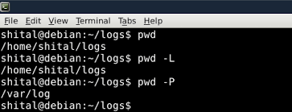

### mkdir command

This mkdir command allows you to create fresh directories in the terminal itself. The default syntax is mkdir <directory name> and the new directory will be created.

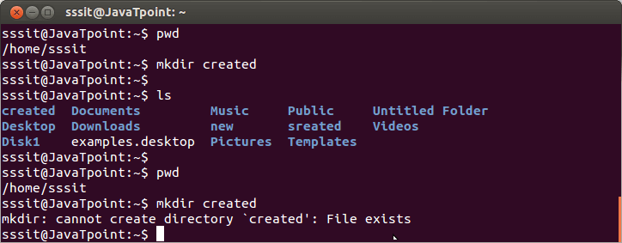

### cd command

The cd command is used to navigate between directories. It requires either the full path or the directory name, depending on your current working directory. If you run this command without any options, it will take you to your home folder.

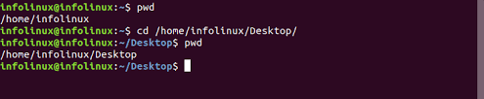

### rmdir command

The rmdir command is used to delete permanently an empty directory. To perform this command the user running this command must be having sudo privileges in the parent directory.

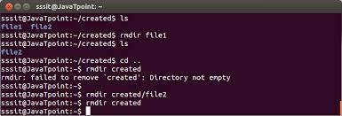

### cp command

### The cp command of Linux is equivalent to copy-paste and cut-paste in Windows. It is used for copying files and directories from one location to another.

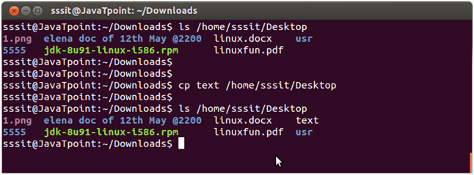

### mv command

The mv command is generally used for moving or renaming the files and directories in Linux.

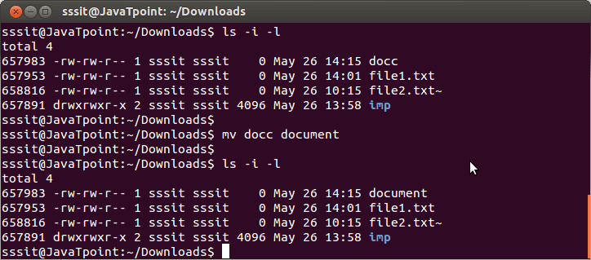

### rm command

### rm command in Linux is generally used to delete the files created in the directory. Be cautious with this command, as deleted data is not easily recoverable.

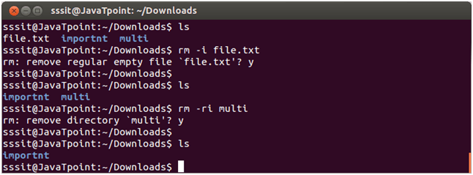

### touch command

The touch command creates an empty file when put in the terminal in this format as touch <file name> or updates the timestamp of existing files.

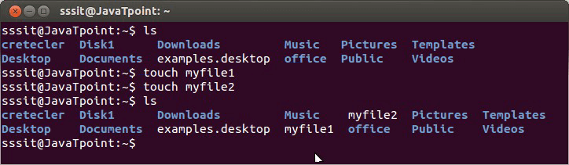

### cat command

The cat command is the simplest command to use when you want to see the contents of a particular file. The only issue is that it simply unloads the entire file to your terminal. If you want to navigate around a huge file, you should use less command alternatively.

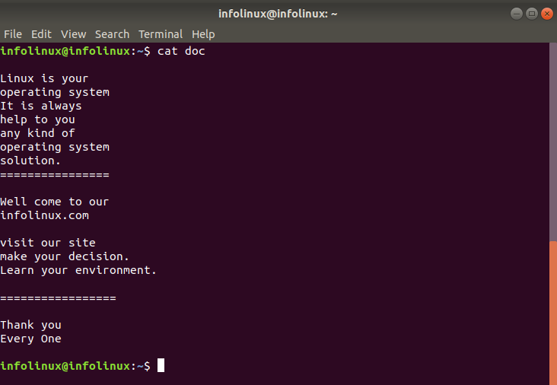

### clear command

### The clear command is a standard command to clear the terminal screen

### echo command

Echo command in Linux is specially used to print something in the terminal

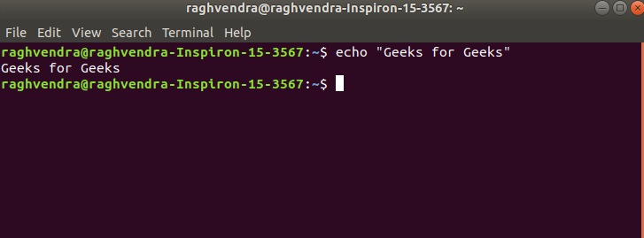

1. **grep command**

The grep command is used for searching text within files. It's a powerful tool for pattern matching and text manipulation.

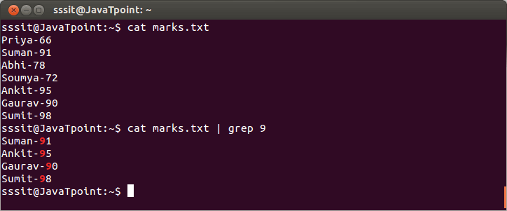

### wget command

The wget command in the Linux command line allows you to download files from the internet. It runs in the background and does not interfere with other processes.

Here is the basic syntax: wget [option] [url]

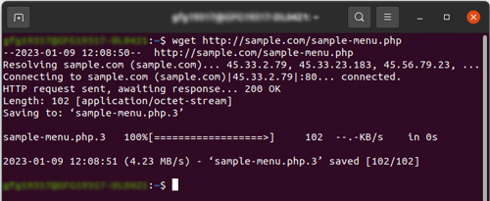

1. **chmod command**

The chmod command is used to change file permissions, specifying who can read, write, and execute a file.